**Advance Excel Assignment 1**

**1. What do you mean by cells in an excel sheet?**

Ans: A cell in an excel sheet is primarily a rectangular area which is created by an intersection within each row and column. They are identified by cell name which is derived by column name and row number For eg: the highlighted cell over here is in B column and 6th row. The best way to get the cell name is to check the name box which is usually on the top left side below the ribbons: We use cells to enter information into the sheet. Which can be used for reference later.

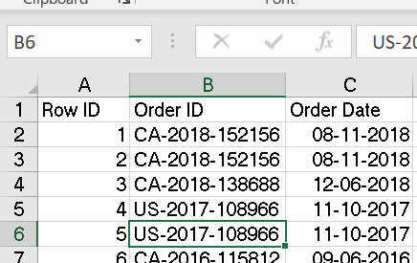

**2. How can you restrict someone from copying a cell from your worksheet?**

Ans. Whenever you wish to protect the data from being copied by unauthorized people, you can click on the **Menu bar** select **Review** then click on **Protect Sheet** and then click on **Password**. Enter your preferred password. After entering the password, we can restrict someone from copying cells from our worksheet.

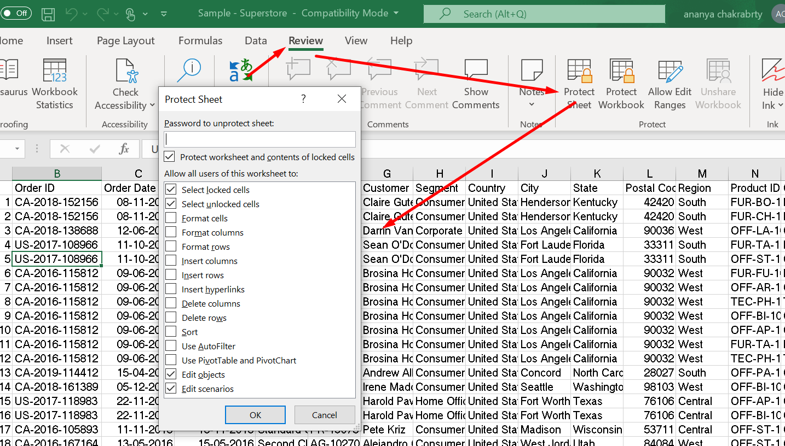

**3. How to move or copy the worksheet into another workbook?   
Ans:** If you want to move or copy the worksheet into another workbook. Follow these   
Steps:  
1. First Open the workbook that has the sheet that you want to move or copy  
2. Second,open the workbook you wish to move the sheet to.  
3. Next, go to the sheet which has the data. Go to the **Home** tab, click   
on the **Format** dropdown, select **Move or Copy Sheet** or right click on the sheet & select **move and copy** sheet  
4. When the dialog box opens up, select the target sheet from the **To Book** dropdown.Excel will display only the open workbooks in this list.  
5.If necessary, please update the Before Sheet selection.  
6. If you want to copy the sheet, click the **Create A Copy** option at the bottom of the dialog.  
7.Click OK and Excel will move or copy the sheet to the target workbook

4. Which key is used as a shortcut for opening a new window document?  
Ans. To quickly create a new workbook press **CTRL+N** & a new window pops up with a blank workbook.

5. What are the things that we can notice after opening the Excel interface?

As soon as we open the Excel Interface, the startup window appears, it contains the tabs or menu bars which showcase Home, Insert, Page Layout, Formulas, Data, Review, View & Help.  
Below each Tab we have Ribbons which showcase all the functions that we can perform in that particular task.  
Below Ribbons we have the formula bar, which showcases the action or the details that are performed in each cell that is selected

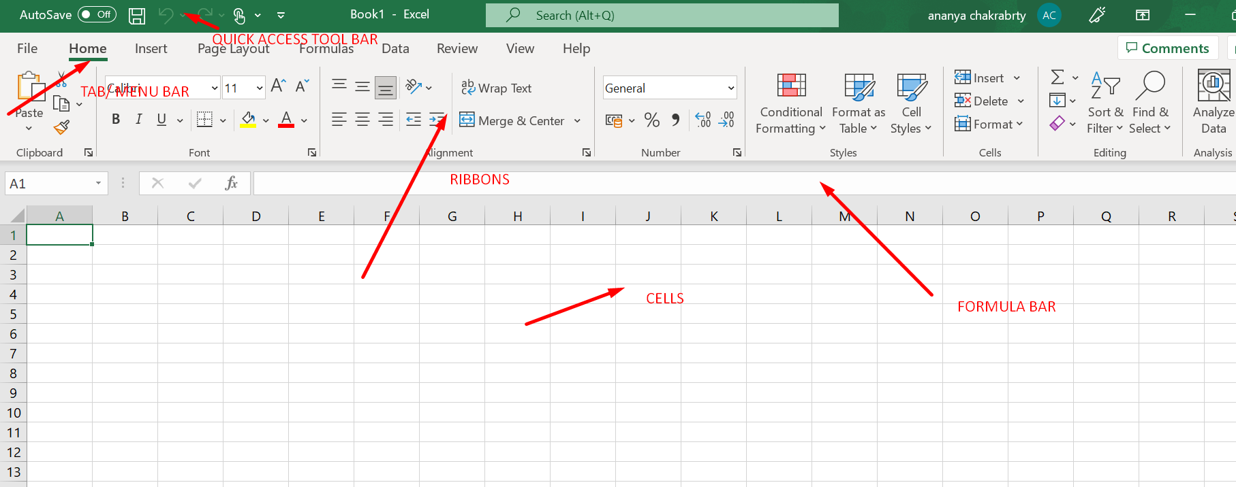

6. When to use a relative cell reference in excel?

Relative reference is a type of cell reference in Excel. This reference changes when the formula is copied to any other cell or any other worksheet. Relative cell references are primarily used whenever calculations need to be repeated.hey adjust and change when copied, or when using AutoFill. In the below example, C3 is using relative reference wherein the formula is copied from C2 and the reference change from A2& B2 to A3 & B3, when the cell changed to C3

